**Lab 02**

**Name : Mai Tien Dat Tran**

**Id: 104207944**

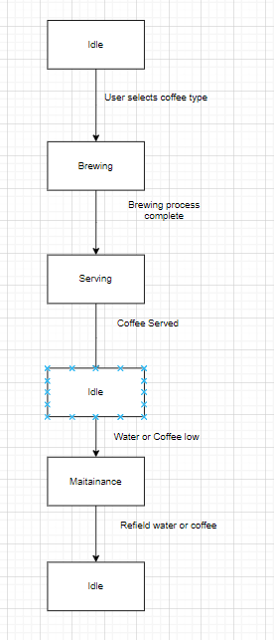

Idle to Brewing: When a user selects a coffee type and there are enough water and coffee beans.

Brewing to Serving: After the brewing process is complete.

Serving to Idle: After the coffee is served.

Idle to Maintenance: When either the water level is too low or the coffee beans level is too low.

Maintenance to Idle: After refilling both water and coffee beans.